1. By convention, All the code in React project we keep that in “src” folder.
2. 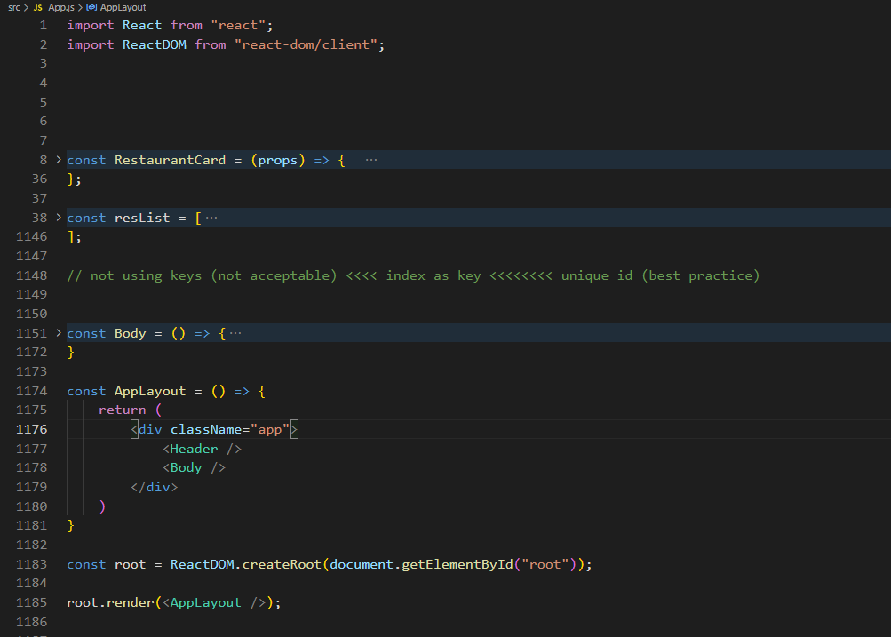

We would be getting below error:

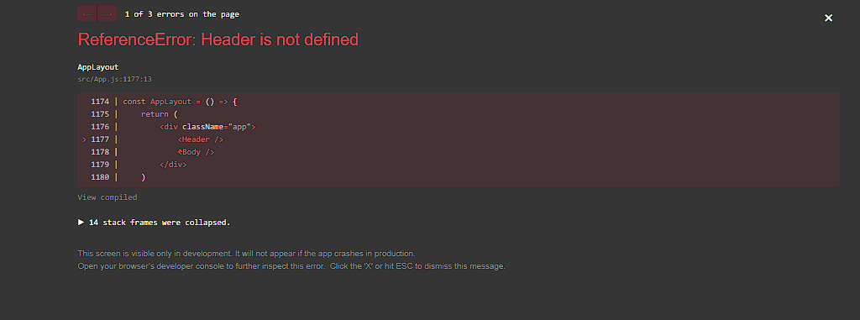

This is because Header component is no longer in above file. It does not recognize it. So, we have to import Header component from the file. But before importing we have to export this component.

* To export the component we’ve to write : export default Header;

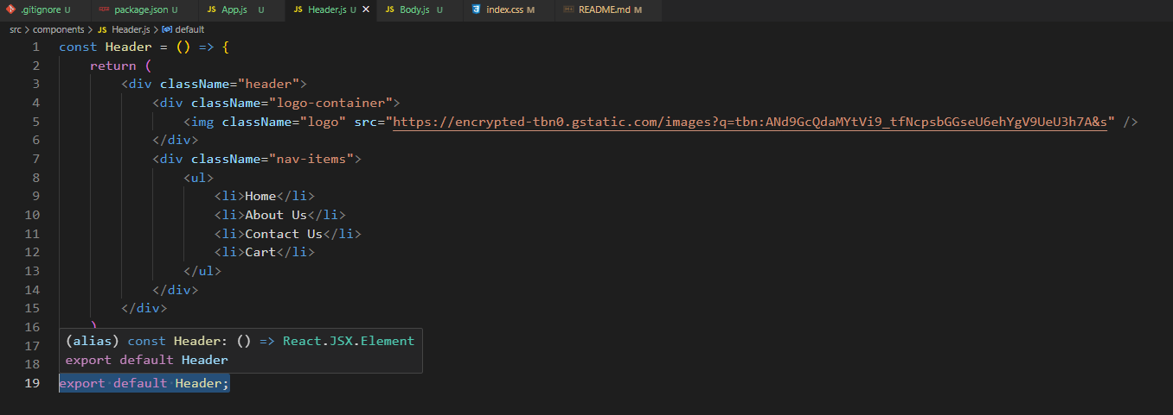

* Now import the Header component : import Header from “./components/Header”

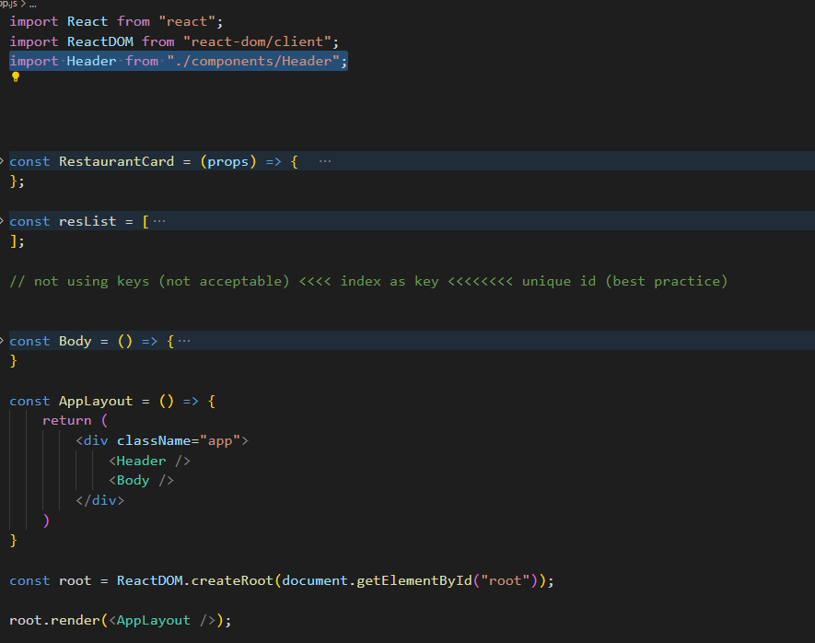

* You’ve to import the component in the file where you are using it.

1. There are 2 types of export:
   * **Default export** : when we’ve to export single thing
   * **Named export** : when we’ve to export multiple things in a single file

* To use named export, we can simple write export in front of const or variable.

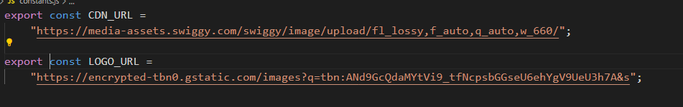

* To import named export => import {CDN_URL} from “../utils/constants”

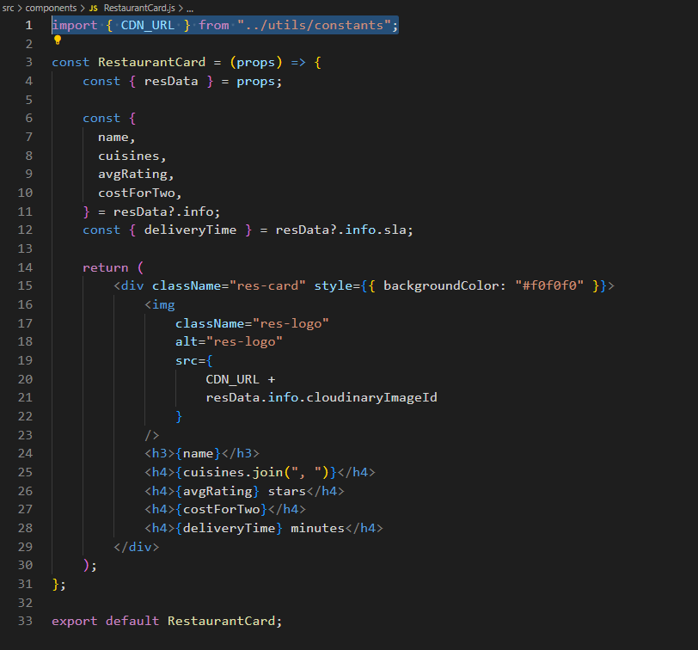

1. **Event Handlers in REACT**:
   * When we’ve button, we have to do something like **onClick.**

* So, we’ll pass an attribute called onClick in button and now this onClick takes a callback function (the function that we’ll pass in callback will be called afte onClick)

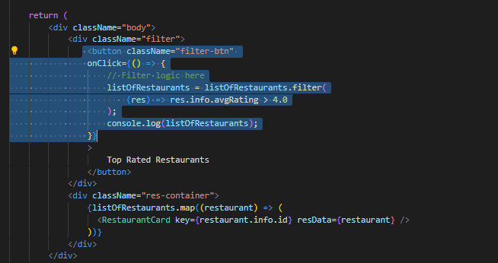

1. Suppose you’ve to keep both UI as well as data layer consistent/tied to each other, that’s where React or any other frameworks (like Vue, Angular, React) comes in picture.
   * React is fast in DOM manipulation. It does efficient DOM manipulation.
2. **REACT HOOKS:** 
   * It is a normal pre-built JS utility function which is given to us by React.
   * This function comes with some superpower which has logic behind scenes inside React.
   * 2 very important Hooks:
     + useState() : used to generate superpowerful variables in react;
     + useEffect()

* When we do *npm install react* => we got all utility function inside our code.
* How do we use utility functions? =? We’ll have to import these.

1. **useState():**
   * First of all, you’ve to import your useState() as named import.
     + ***import { useState } from “react”;***

* To create state variables, we use useState().
  + Why state variable? => because it maintains the state of the component
* How do you create useState() variable?
  + ***const [listOfRestaurants] = useState();***
* When you would call useState(), it will give you state variable.
  + You’ll receive useState() variable inside an array.
  + ***const [listOfRestaurants] = useState([]);***
* What if we want to modify listOfRestaurants?
  + We would do this with the help of a function that would come as a 2nd parameter inside array.
  + ***const [listOfRestaurants, setListOfRestaurants] = useState([]);***

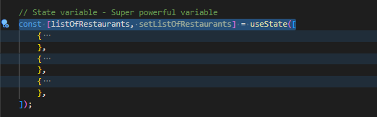

* How would we update listOfRestaurant when we click the button?
  + I’ll call setListOfRestaurant and pass it in new data which I want to push inside it.

